Alaska Earthquake and Tsunami Tabletop Exercise
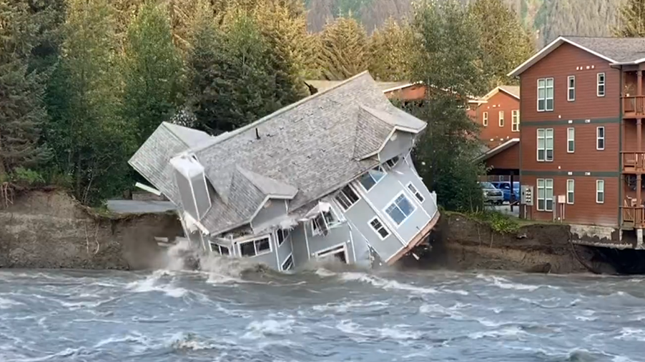  Above: House collapsing in Juneau after the Mendenhall Glacier Release. Picture from Junea Community FB Page.  Below: Two people walking between buildings during Kotzebue flooding Fall 2024. Picture from the Kotzebue Community FB Page  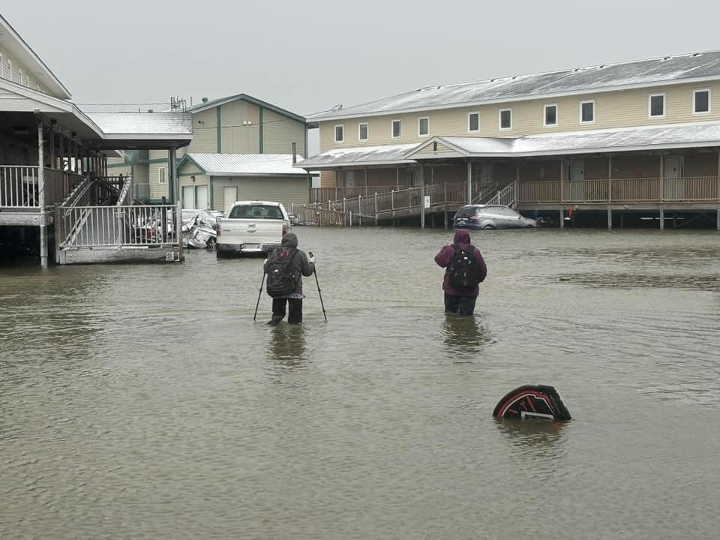 |  | Purpose of the Exercise:  - Enhance community readiness  - Evaluate current emergency response plans  - Identify gaps and areas for improvement  - Develop strategies to support all community members effectively  - Foster Partnerships and communication among organizations  Your Participation Matters:  Seeing different perspectives and hearing from people with differing expertise helps ensure that our preparedness efforts are inclusive and effective.
December 4, 2024 9:30-12:30
Register here: Meeting Registration - Zoom
THE PARTNERSHIP FOR INCLUSIVE DISASTER STRATEGIES
Disaster Resources – The Partnership for Inclusive Disaster Strategies
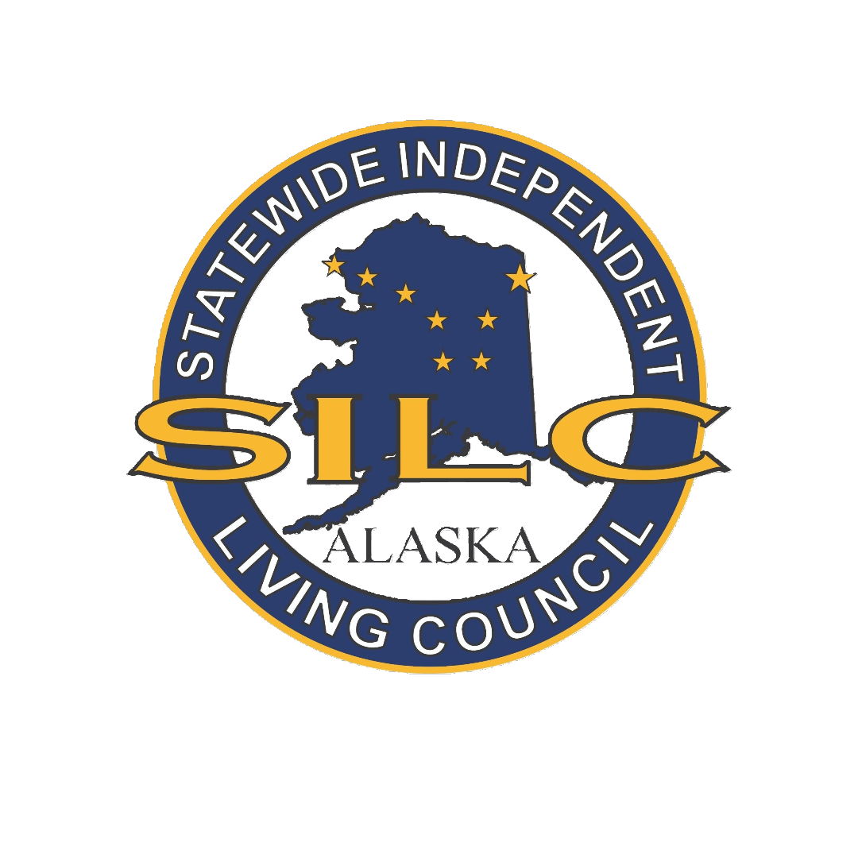 |  | SILC of Alaska  907-263-2011 Lisa@AlaskaSILC.org  www.AlaskaSILC.org

